### Estimation of Business Expenses

**Introduction:**

This is deals into the fascinating realm of business expenses and provides a visual exploration of the various expenditures incurred by different businesses. It showcases the distribution of expenses, identifies key cost drivers, and highlights areas of potential optimization or concern. The visual representations allow for intuitive analysis, facilitating a deeper understanding of expenditure patterns and their implications for business performance. Decision-makers, financial analysts, and stakeholders can gain valuable insights into the financial health of businesses, identify areas of inefficiency or opportunity, and make informed decisions to optimize resources and drive growth. To Extract the Insights from the data and put the data in the form of visualizations, Dashboards and Story we employed Tableau tool.

**Purpose:**

The primary business requirements for this report are to visualize and analyze business expenses, provide industry-specific insights, identify cost drivers, highlight outliers, and offer interactive functionality. Stakeholders need a visual representation of expenses to compare and analyse spending patterns across different businesses and industries. The report should facilitate the identification of key cost drivers, enabling stakeholders to understand the primary factors contributing to expenses. Additionally, it should flag any outliers or anomalies for further investigation.

**Conclusion & Future Scope**

The analysis of business expenses and financial management has a significant social impact. It contributes to economic stability by optimizing costs and fostering long-term sustainability. Effective expense management creates job opportunities and supports the workforce. It allows for better resource allocation, enabling businesses to invest in innovation and community engagement. Responsible expense management aligns with societal expectations and promotes social responsibility. Non-profit organizations benefit from expense analysis, enabling them to maximize their impact. Overall, analysing and managing expenses positively influence economic growth, employment, stakeholder well-being, and social responsibility.

**Screenshot of Brainstorming Map:**

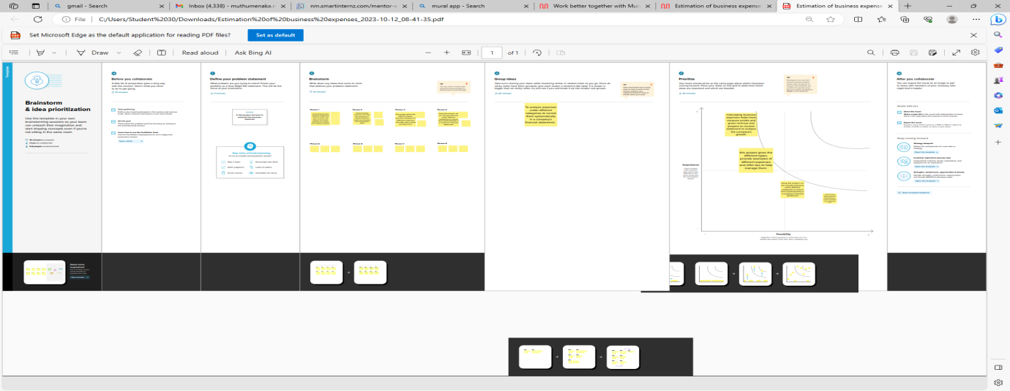

**Screenshot of Empathy Map:**

